**Week 7**

**12. ReactJS – HOL**

**FILE STRUCTURE  
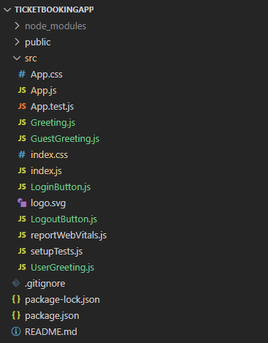  
  
  
CODE**

*C:\Users\User\Desktop\ticketbookingapp\src\App.js*

import React, { useState } from 'react';

import Greeting from './Greeting';

import LoginButton from './LoginButton';

import LogoutButton from './LogoutButton';

function App() {

  const [isLoggedIn, setIsLoggedIn] = useState(false);

  const handleLoginClick = () => {

    setIsLoggedIn(true);

  };

  const handleLogoutClick = () => {

    setIsLoggedIn(false);

  };

  return (

    <div>

      <h1>Ticket Booking App</h1>

      <Greeting isLoggedIn={isLoggedIn} />

      {isLoggedIn ? (

        <LogoutButton onClick={handleLogoutClick} />

      ) : (

        <LoginButton onClick={handleLoginClick} />

      )}

    </div>

  );

}

export default App;

*C:\Users\User\Desktop\ticketbookingapp\src\Greeting.js*

import React from 'react';

import GuestGreeting from './GuestGreeting';

import UserGreeting from './UserGreeting';

function Greeting(props) {

  const isLoggedIn = props.isLoggedIn;

  if (isLoggedIn) {

    return <UserGreeting />;

  }

  return <GuestGreeting />;

}

export default Greeting;

*C:\Users\User\Desktop\ticketbookingapp\src\GuestGreeting.js*

import React from 'react';

function GuestGreeting() {

  return (

    <div>

      <h2>Please Sign up.</h2>

    </div>

  );

}

export default GuestGreeting;

*C:\Users\User\Desktop\ticketbookingapp\src\UserGreeting.js*

import React from 'react';

function UserGreeting() {

  return (

    <div>

      <h2>Welcome back</h2>

      <p>Flight Details:</p>

      <ul>

        <li>Flight: AI209</li>

        <li>From: Kolkata</li>

        <li>To: New Delhi</li>

        <li>Departure: 8:00 AM</li>

        <li>Arrival: 10:00 AM</li>

      </ul>

      <button>Book Ticket</button>

    </div>

  );

}

export default UserGreeting;

*C:\Users\User\Desktop\ticketbookingapp\src\LoginButton.js*

import React from 'react';

function LoginButton(props) {

  return <button onClick={props.onClick}>Login</button>;

}

export default LoginButton;

*C:\Users\User\Desktop\ticketbookingapp\src\LogoutButton.js*

import React from 'react';

function LogoutButton(props) {

  return <button onClick={props.onClick}>Logout</button>;

}

export default LogoutButton;

**OUTPUT**

